Chairman: A. Morley Secretary: B. Hayes,
FRIENDS OF COOMBE WOOD
Treasurer: T.Isherwood 84 Kenneth Road,
Thundersley SS7 3AN
hulmecottage@hotmail.com
01268 792170

Newsletter October 2005

Since our newsletter in April 2005 there has been some developments. As previously reported the recommendations of the Inspector to our application were subject to the outcome of the Village Green application in Oxfordshire. The Oxfordshire case has now been successful in being granted leave to appeal in the House of Lords, but the earliest possible date will not be until after March 2006. Another bit of news is that next year a new Commons Land Bill is expected to clarify the law in respect of Town and Village Green applications and we anticipate this will benefit the Coombe Wood application.

The main legal issues relate to whether a landowner can prevent registration by fencing the land or whether an inspector can recommend an area of land substantially smaller than what was being requested within the application.

Essex County Council is unlikely to make any decision on our application until the above legal issues have been resolved and therefor it will be some considerable time before we have a final verdict. Members of Friends of Coombe Wood should note that the AGM for 2005 will be postponed until a decision is made by the Essex County Council.

It should be noted that when our application was being processed up to the public hearing stage, three other Town and Village Green applications were being considered. All three applications were successful and none were constrained by the outcome of the Oxfordshire case, as it was with the Commbe Wood application. We believe our application is being stringently judged at this stage and as a result consider there are sufficient grounds for a judicial review if the current recommendations by the Inspector are not changed.

Although our questionnaire on the use of the land by local inhabitants was a six-page document, the Inspector devalued it due to the fact that he could not deduce the ‘frequency and geographical extent of the various activities alleged to have take place’. This was because the questionnaire ‘gave no indication what particular part of the woods were used’. However we now have an opportunity to update the evidence previously submitted to the inquiry up until Essex County Council make their decision. As a result we enclose a couple of further questions for which we would appreciate your contribution. Could you please complete the attached and return the form to our secretary in the enclosed envelope.
FRIENDS OF COOMBE WOOD

Questionnaire part 2

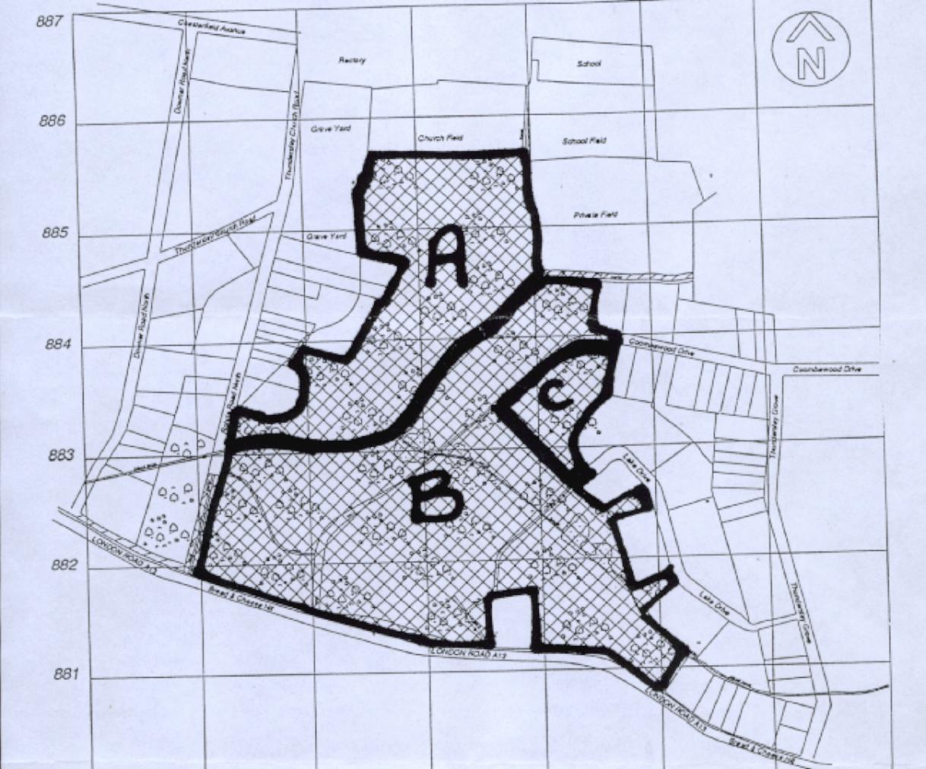
Please tick as appropriate. Enter 1 for yourself or the number of people/children used with you e.g. Scouts group or friend/family

Area A never used or used by

Area B never used or used by

Area C never used or used by

Print FULL NAME ………………………………………………….

SIGN ……………………….. DATE ……………………….

Please return to B Hayes 84 Kenneth Road Thundersley, Essex SS7 3AN

FRIENDS OF COOMBE WOOD

Questionnaire part 1

The Inspector, in his recommendations, divided Coombe Wood into three distinct areas being

Land to the north of the brook - excluded for registration
Land to the south or the brook - included for registration
Land to the south or the brook - excluded for registration

These areas are marked on the attached plan

When you complete this part 2 of your questionnaire could you please indicate whether any of these areas should be excluded or included by marking the plan accordingly and returning it to us. Please remember to sign and date the plan

If you have been involved in using the woods with others, i.e. friends or groups (organised or not) please indicate the number of people/children involved.

